

Name: Sajjal Tariq
Roll No: 10011
Section: A
Submitted To: Sir Zohaib Khan

LAB NO. 5

Simple SQL Queries and Constraints

To practice and implement data definition language commands and
constraints.

Instructions
▪ This is individual Lab work/task.
▪ Complete this lab work within lab timing.
▪ Discussion with peers is not allowed.
▪ You can consult any book, notes &amp; Internet.
▪ Copy paste from Internet will give you negative marks.
▪ Lab work is divided into small tasks, complete all tasks sequentially.
▪ Show solution of each lab task to your Lab Instructor.
▪ Paste your solution (i.e. code) in given space under each task.
▪ Also make a zip/rar archive of all lab tasks and upload this file on LMS before
leaving lab.
▪ In-Lab Exercises/Tasks

FACILITIES REQUIRED AND PROCEDURE
Facilities required to do the experiment

S.No
.
Facilities Required Quantity

1 System 1
2 Operating System Windows 10
3 Front End Java
4 Back End Oracle 11g, MySQL

Procedure for doing the experiment

Step Details
1 Check Constraint:

Check constraint can be defined to allow only a particular range of
values. When the manipulation violates this constraint, the record will
be rejected. Check condition cannot contain sub queries.

2 b) Entity Integrity

Maintains uniqueness in a record. An entity represents a table and
each row of a table represents an instance of that entity. To identify
each row in a table uniquely we need to use this constraint. There are
2 entity constraints:
Unique Key Constraint
It is used to ensure that information in the column for each record is
unique, as with telephone or drivers license numbers. It prevents the
duplication of value with rows of a specified column in a set of column.
A column defined with the constraint can allow null value.
If unique key constraint is defined in more than one column i.e.,
combination of column cannot be specified. Maximum combination of
columns that a composite unique key can contain is 16.

Primary Key Constraint
A primary key avoids duplication of rows and does not allow null
values. It can be defined on one or more columns in a table and is
used to uniquely identify each row in a table. These values should
never be changed and should never be null. A table should have only
one primary key. If a primary key constraint is assigned to more than
one column or combination of column is said to be composite primary
key, which can contain 16 columns.

3 c) Referential Integrity

It enforces relationship between tables. To establish parent-child
relationship between 2 tables having a common column definition, we
make use of this constraint. To implement this, we should define the
column in the parent table as primary key and same column in the
child table as foreign key referring to the corresponding parent entry.
Foreign key
A column or combination of column included in the definition of
referential integrity, which would refer to a referenced key.
Referenced key
It is a unique or primary key upon which is defined on a column
belonging to the parent table.

SQL COMMANDS

CHECK CONSTRAINT
Example: Create table student (regno number (6), mark number (3) constraint b check
(mark &gt;=0 and mark &lt;=100));
Alter table student add constraint b2 check (length(regno&lt;=4));

Entity Integrity
Unique key constraint
Example: Create table cust(custid number(6) constraint uni unique, name char(10));
Alter table cust add(constraint c unique(custid));

Primary Key Constraint
Example: Create table stud(regno number(6) constraint primary key, name char(20));

Tasks
Q1. Create a table called EMP with the following structure.
Name Type
---------- ----------------------
EMPNO NUMBER(6)
ENAME VARCHAR2(20)
JOB VARCHAR2(10)
DEPTNO NUMBER(3)
SAL NUMBER(7,2)
Allow NULL for all columns except ename and job.

Answer:
1. Understand CREATE TABLE syntax.
2. Use the CREATE TABLE syntax to create the said tables.
3. Create a primary key constraint for each table as you understand from logical table
structure.

Code:

SQL> CREATE TABLE student (
2 student_id NUMBER(6) PRIMARY KEY,
3 student_name VARCHAR2(20) NOT NULL,
4 course VARCHAR2(10) NOT NULL,
5 semester NUMBER(3),
6 fee NUMBER(7,2)
7 )

Output:
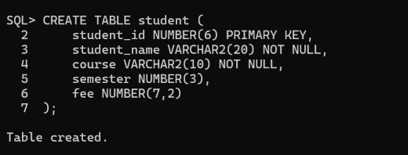

Q2: Add a column experience to the emp table. Experience numeric null allowed.

Answer:
1. Learn ALTER TABLE syntax.
2. Define the new column and its data type.
3. Use the alter table syntax.
Code:
ALTER TABLE student
2 ADD experience NUMBER;

Output:


Q3: Modify the column width of the job field of emp table.
Answer:
1. Use the alter table syntax.
2. Modify the column width and its data type.

Code:

ALTER TABLE student
2 MODIFY course VARCHAR2(20);

Output:



Q4: Create a department table with the following structure.
Name Type
------------ ---------------------
DEPTNO NUMBER(2)
DNAME VARCHAR2(10)
LOC VARCHAR2(10)
Deptno as the primary key

Answer:

1. Understand CREATE TABLE syntax.
2. Decide the name of the table.
3. Decide the name of each column and its data type.
4. Use the CREATE TABLE syntax to create the said tables.
5. Create a primary key constraint for each table as understood from the logical table
structure.

Code:

CREATE TABLE department (
deptno NUMBER(2) PRIMARY KEY,
dname VARCHAR2(10),
loc VARCHAR2(10)
);

Output:



Q5. Create a table called staff with the following structure.
Name Type
---------- ----------------------
EMPNO NUMBER(6)
ENAME VARCHAR2(20)
JOB VARCHAR2(10)
DEPTNO NUMBER(3)
SAL NUMBER(7,2)
Deptno as a foreign key

Answer:
1. Understand the CREATE TABLE syntax.
2. Use the create table syntax to create the said tables.

3. Create foreign key constraint for each table as you understand from logical table
structure.

Code:
SQL> CREATE TABLE staff (
2 empno NUMBER(6),
3 ename VARCHAR2(20),
4 job VARCHAR2(10),
5 deptno NUMBER(3),
6 sal NUMBER(7,2),
7 FOREIGN KEY (deptno) REFERENCES department(deptno)
8 );

Output:

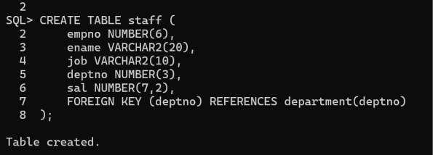
Table created.

Q6: Create the emp1 table with ename and empno, add constraints to check the
empno value while entering (i.e) empno &gt; 100.
Answer:
1. Learn alter table syntax.
2. Define the new constraint [columns name type]
3. Use the alter table syntax for adding constraints.

SQL&gt; create table emp1(ename varchar2(10), empno number(6) constraint ch
check(empno&gt;100));

Table created.
Code:

SQL> CREATE TABLE student1 (
2 student_name VARCHAR2(20),
3 student_id NUMBER(6) CHECK (student_id > 100)
4 );
Output:
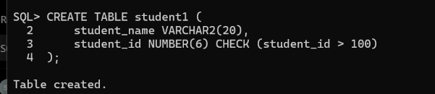

OUTCOME
Thus the data definition language commands was performed and implemented
successfully

QUESTIONS AND ANSWERS
Define the terms
DDL:
Data base schema is specified by a set of definitions expressed by a special language
called a data definition language.
What are the categories of SQL command?
SQL commands are divided in to the following categories:
Data Delimitation language
Data manipulation language
Data control language
Transaction Control Language
What is integrity constraint?
An integrity constraint is a mechanism used by oracle to prevent invalid data entry into
the table. It has enforcing the rules for the columns in a table.
List the types of constraint.
Domain Integrity
Entity Integrity
Referential Integrity
Primary Key Constraint
A primary key avoids duplication of rows and does not allow null values. It can be
defined on one or more columns in a table and is used to uniquely identify each row in a
table. These values should never be changed and should never be null.
Referential Integrity
It enforces relationship between tables. To establish parent-child relationship between 2
tables having a common column definition, we make use of this constraint. To
implement this, we should define the column in the parent table as primary key and
same column in the child table as foreign key referring to the corresponding parent
entry.

